**Synopsis Report**

**on**

**ELECTRICSTAIRS**

***Submitted in partial fulfillment of the***

***Requirements for the award of the degree***

***of***

BACHELORS OF ENGINEERING

in

MECHATRONICS ENGINEERING

**Submitted By: - Faculty Supervisor: -**

SUDEEP YADAV (19BEM1027) Mrs. JASPINDER KAUR



**UNIVERSITY INSTITUTE OF ENGINEERING**

**CHANDIGARH UNIVERSITY**

**GHARUAN, MOHALI, PUNJAB, INDIA-140413**

**2019**

|  |  |  |
| --- | --- | --- |
| **INDEX** | | |
| **Sr. No** | **Content** | **Pg. No** |
| **1** | **CANDIDATE’S DECLERATION** | **2** |
| **2** | **INTRODUCTION** | **3** |
| **3** | **LITERATURE REVIEW** | **3 - 4** |
| **4** | **METHODOLOGY**   * **OBJECTIVE** * **STEPS INVOLVED** | **4 - 6** |
| **5** | **BLOCK DIAGRAM** | **6** |
| **6** | **REQUIRED ELEMENTS & DESCRIPTION OF PARTS** | **6 - 9** |
| **7** | **Approximate Cost and Total Cost** | **9** |
| **8** | **WORK PLAN** | **10** |
| **9** | **ACKNOWLADGEMENT** | **11** |
| **10** | **REFERENCE** | **12** |

|  |  |  |
| --- | --- | --- |
|  |  |  |
|  |  |  |
|  |  |  |
|  |  |  |

**CHANDIGARH UNIVERSITY, GHARUAN, MOHALI**

**CANDIDATE'S DECLARATION**

I “Sudeep Yadav” hereby declare that the work embodied in this synopsis entitled **“Electricstairs”** in partial fulfillment of requirements for the award of degree of B.E (MECHATRONICS ENGINEERING) at **CHANDIGARH UNIVERSITY GHARUAN, MOHALI.** The work which is being presented in this synopsis submitted to **Department of Mechatronics Engineering** is an authentic record of bonafide piece of work.

Signature

(SUDEEP YADAV)

Supervisor Signature

(Name and Designation)

**INTRODUCTION**

Due to rising energy prices and increased environmental awareness, there is a growing need for sustainable designs. The world has embraced this concept by establishing solar panels, wind turbines, etc. Instead of looking for new ways to generate energy, we should be focusing on harvesting energy from everyday activities. Steps and stairs are an essential part of the building and every small building has some floors. While climbing upstairs, we found that a lot of human energy gets wasted when we are stepping on the floor by the waste of heat and friction, we can harvest it rather than simply letting it go. We saw there is a great possibility of harvesting this energy and generating power by making every staircase as a power generation unit. And from there we started our project which is named Electricstairs. By the means of Electricstairs we are trying to harvest the energy in two ways, one is the gear and motor arrangement mechanism that takes the staircase power and converts the power to an electrical source, and the other one is a piezoelectric generator that harvests mechanical vibrations energy available on a Staircase. The generated power then can be stored in batteries or we can use an inverter circuitry and use it as convention electricity at our household plugs which has an output of 220 volts. The generated electricity will be totally free of cost and it will be used as per our own needs and purposes. It’s free of cost eco-friendly energy which is easily useable and as far as we know this is a non-conventional power generation system when we compared it with the existing systems.

.

**LITERATURE REVIEW:**

* An investigation on generation of electricity using foot step 2015 Siba brata Mohanty, Sasank Shekhar Panda, Research scholar, Department of Industrial Engineering, G.I.E.T, Gunupur. Rayagada, India Research scholar, Department of Mechanical system Design, G.I.E.T, Gunupur. Rayagada, Odisha.The objective of this work is power generation through footsteps as a source of renewable energy that we can obtained while walking on to the certain arrangements like footpaths, stairs, Plate forms and these systems can be installed elsewhere specially in the densely populated areas. The basic working principle of “footstep power generation system” is based on the crank shaft and gear arrangement and fly wheel.

Staircase Power Generation Using Piezo-Electric Transducers, November 6,2013 Produced by V. Prasannabalaji, R. Rakesh, S. Sairam and S. Mahesh from Electronics and Instrumentation Engineering, Sri SaiRam Engineering College, Chennai. They offer a promising approach as an efficient method to reduce our dependence on conventional source of electricity. Besides the power generation through piezoelectric materials being a non-conventional approach, helps to reduce the environmental pollution.

**METHODOLOGY**

**Objective:**

We plan to harvest energy from the everyday motion of people. We want that the energy supplied by humans should be utilized in some form rather than wasting it entirely and so we made Electricstairs. Our Electricstairs project generates electric power without polluting our environment and so our system is very eco-friendly from an environmental point of view. The energy source is continuous and renewable. Our main objective of this project is to harvest as much energy as possible, without compromising the reliability and safety of traditional stairs. we want look forward to practically implement our project on a university level so that we as students can also contribute to some sort of waste energy harvesting and utilization. Moreover, we are confident that this method of electric energy generation will be used for rural electrification and to fulfil the growing power needs of the world as well. The harvested energy will be available to the user in 2 different forms: either direct 12 v output or 220 v alternating output. The possibilities are endless and do not limit the user’s usage.

**Steps Involved**

We are using here two merged method for harvesting the waste human power.

1. Piezoelectric crystal patches/ plates.
2. Alternator with gear arrangement mechanism assembly.

Piezo electric crystals are said to give an output of about 13 volts on an average but after performing experiment practically we found that each piezoelectric plate was providing around 1.3-1.5 volts after the entire processing with sufficient amount of current. So, as our project is having 24 individual piezo electric plates so we divided them into pair of 2 where each pair will be interconnected in parallel combination resulting in 12 pairs yielding about 15 - 18 volts as output. We rectify it and pass it through a ripple neutralizer because piezoelectric plates produce AC outputs. Then we pass this voltage through a voltage regulator and filtration circuit which regulates the output voltage to 12 volts and soothes the output preventing it from voltage spikes or fluctuations.

An alternator acts as a second source of produced electricity and it produces directly in DC form. On an average, a dc alternator produces DC output of about 13-15v but with high current, much higher than piezoelectric plates. Our special gear mechanism assembly pays a very vital role here. It’s working mechanism is such that irrespective of a push or a pull, it always turns the rotor of the alternation in one direction only. Resulting in continuous dc output. (an image of mechanism is given below:

Then we regulate the output voltage to 12v as we did earlier by using a voltage regulator and filtration circuit and hence, we get clean smooth 12 v output.

So now we have 12 volts output from 2 sources one from piezoelectric and the other from DC alternator then we merge both of these 12 volts from different sources together my using a merging circuit and hence as a result we get a clean output voltage of 12 volts with sufficient amount of current which can further be used in any form of electricity.

We are by default adding 2 options for the user to use the output from Electricstairs, one is 12 volts DC direct which will be available in a DC jack and the other option is by having an inverter circuitry. This inverter circuit will convert from 12v volt DC to 220 volts AC, (same as our home invertors work) allowing the user to connect all 220 v electronics like laptop chargers, phone chargers battery charger modules etc. to work for free, at zero cost of electricity.

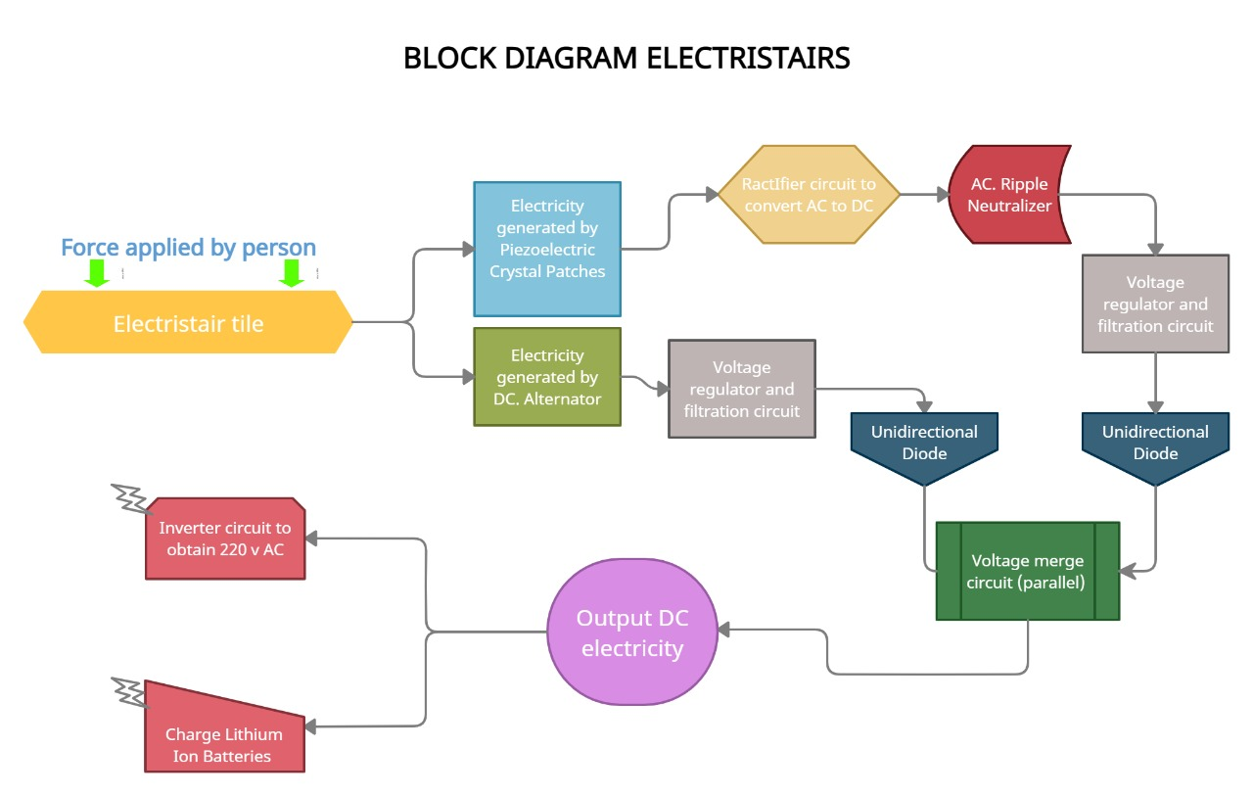

**DESCRIPTION OF PARTS:**

**GEAR ARRANGEMENT**

In this project we are using spur gear with rack and pinion arrangement along with: springs, rods, alternator holder clamp, stair tile, and stair base. When stair will be pressed due to someone’s weight while climbing up the stairs then rack will be pushed down which will simultaneously press spring which is connected at its bottom and the teeth of rack will mesh together with those of pinion gears which have approx. half circumference of teeth, enabling the rotor of alternator to rotate in clockwise direction. Once the rack is fully pressed and reaches the bottom, now the real magic of this assembly happens. At present the spring is at its full compression, so when someone lifts up his foot from stair spring reverses the rack back to its original position but 2nd pinion gear starts to mesh turning the rotor of alter again in clockwise direction rather than anticlockwise.

Hence, in short, the gear mechanism allows the **motor to rotate in one direction** **only** irrespective of we push down or pull up the stair tile of Electricstairs, which as a result produces enormous amount or electrical energy because there are **4 such gear assemblies and 8 DC Alternators.**

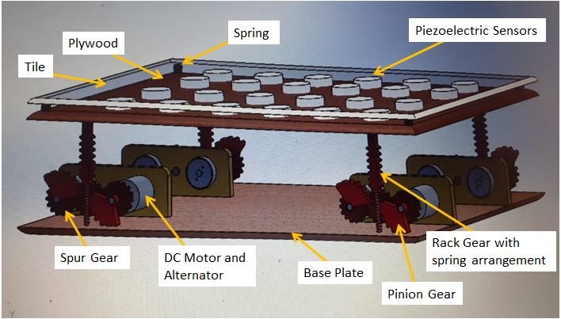

**PIEZOELECTRIC CRYSTAL:**

Piezoelectric crystal plates or patches are placed in the gap between the top plate and the intermediate tile and are used to convert the mechanical energy into electrical energy by the means of Piezo-electric effect. **Piezoelectric Effect** is the effect due to which some materials generate an electric charge in response to applied mechanical stress. They are mainly used as sensors of pressure or force for research and development in various industries. The applications of this sensor involve, aerospace, medical, nuclear instrumentation, and as a pressure sensor it is used in the touch pad of mobile phones. In basic terms, they are actually transducers, because they convert energy from one form to another (in this case from mechanical to electrical).

**DC- ALTERNATOR:**

A DC Alternator is an electrical energy generator, that converts mechanical energy to electrical energy in the Direct Current form. the rotary motion of the shaft of the alternator produces electricity as an output, and in our project, we are converting linear to rotary motion to achieve the desired output electricity.

**RECTIFIER:**

A Rectifier is an electronic circuit that converts Alternating Current (AC) to Direct Current (DC) at its output.

The process is known as rectification since it will "straighten" the direction of the current.

**AC RIPPLE NEUTRALIZER:**

A Ripple Neutralizer is a device that is used to remove the ripples from the output of the rectifier and smoothens the output wave which is received from the filter, and it is constant up to the load and main voltage remains constant. Though, if any of the two is varied, then the received DC voltage at this point will change. For that, a regulator is applied to the output stage.

**7812 VOLTAGE REGULATOR:**

A Voltage Regulator is an electronic device which maintains a constant output voltage at a certain level. For example; a 12 volts voltage regulator will always deliver constant 12 volt as output if the input provided varies between 12 -20 volts. It uses a simple feed-forward design or a negative feedback loop system.

**FILTRATION CIRCUITRY:**

The ripple in the signal denotes the existence of some AC component. This AC component will completely remove for to get pure DC output. So, we have to build a circuit that smoothens the rectified output into a pure DC signal. Most of the filtration circuits include capacitors and some basic electronic components.

**UNIDIRECTIONAL DIODE:**

A Diode is a simple semiconductor electronics device that basically acts as a one-way switch for current. It allows current to flow easily in only one direction, but mortally oppose the current from flowing in the opposite direction.

**MERGED CIRCUIT:**

As we are taking the voltage from the piezoelectric method as well as from gear mechanism, so we require to merged them in parallel combination. This is done by the merge circuit.

**DC CONNECTOR PLUG:**

This plug will be at the last after the whole process gets completed. It is used so that user can directly use 12 volts DC if he wants to use it somewhere. For example: for charging batteries for other DC applications etc.

**CONNECTING WIRES:**

Wires are necessary part of every system and they are used for electrical connection between various electronic devices.

**Approximate Cost of project:**

GEAR MECHANISM ASSMBLY 1 x 800 = 800

PIEZOELECTRIC CRYSTAL PATCHES / PLATES: 8 X 24 = 192

DC- ALTERNATOR: 200 X 8 = 1600

RECTIFIER: 1 X 50 = 50

AC RIPPLE NEUTRILIZER: 1 X 80 = 80

7812 VOLTAGE REGULATORS: 2 X 10 = 20

FILTRATION CIRCUITRY: 2 X 50 = 100

UNIDIRECTIONAL DIODE: 2 X 5 = 10

MERGED VOLTAGE STORAGE: 1 X 20 = 20

DC JACK: 1 X 20 = 20

CONNECTING WIRES: 100 RS (APPROX)

**TOTAL COST 2992 Rs or Rs: 3000 (approx.)**

**Work plan and work distribution:**

* Every team member has equally participated and contributed towards the making and implementation of this project toward success.
* However, **Sudeep** came up with excellent Idea of Electricstairs and also helped the team by providing some 3D visualization for the various parts.
* **Preetinder** helped the team by providing all the technical knowledge for improved structure and design of the Electricstairs.
* **Shashwat** provided the required calculation for better efficiency and output of the project along with some minor detailing and presentation.
* All the theoretical help was provided by **Sankhyadip** which include important articles related to the topic and other content like YouTube videos and all.

**PENDING WORK:**

As we all know, whole world is facing COVID-19 situation. So, it would not be possible for us to meet and give the project its final touch. So as per the situation we have made our project with the simulation part only. Further we will update it as a realistic version. Also, we will try increase the efficiency and effectiveness of the mechanism to collect more electrical power from human energy. We also look forward to implement our Electricstairs in crowded places like university campuses, subways/ metro stations, railway stations community buildings etc. in coming few years.

**ACKNOWLEDGEMENT**

It gives me proud privilege to complete this mid semester project. This is the only page where I have the opportunity to express my emotions and gratitude. It is great pleasure in expressing sincere and deep gratitude towards my supervisor and guide Mrs. Jaspinder Kaur for her valuable suggestions, guidance, and constant support throughout the completion of this project named “Electricstairs”. I am really very thankful to Chandigarh University for providing me such a great opportunity to make such a wonderful project which can solve real-life problems and extremely valuable hands-on experience along with crucial soft skills such as working in a team, communication skills, and much more. I also offer my most sincere thanks to every team member of our group who was working rigorously on this project and staff members of the Mechatronics Department, University Institute of Engineering, Chandigarh University for cooperation provided by them in every possible way.

7th MAY, 2021 SUDEEP Yadav

**REFERENCES:**

[1Power Generation Using Foot Step 2011 v.Jose Ananth Vino, AP, Bharath University .

[2] Staircase power Generation Using Piezo-Electric Transducers 2013V. Prasannabalaji, R.Rakesh, S. Sairam and S. Mahesh Electronics and Instrumentation Engineering, Sri SaiRam Engg College, Chennai.

[3] Electricity generation from Footsteps 2010 S.S.Taliyan, B.B. Biswas, R.K. Patil and G. P.Srivastava Reactor Control Division, Electronics & Instrumentation Group and T.K. Basu IPR,Gandhinagar

[4] An investigation on generation of electricity using foot step 2015 Siba brata Mohanty, Sasank Shekhar Panda, Research scholar, Department of Industrial Engineering, G.I.E.T, Gunupur

[5] Power Generation from Staircase (Steps) 2014 Ramesh Raja R1, Sherin Mathew, UG Scholars, Department of Mechanical Engineering, RVS College of Engineering & Technology Dindigul, India

[6] Electricity Generation from Footsteps; A Regenerative Energy Resource 2013 Tom Jose V, Binoy Boban, Sijo M T SCMS School of Engineering and Technology, Kochi

[7] Power Generation Footstep 2014 Shiraz Afzal, Farrukh Hafeez Electronic Engineering Department, Sir Syed university of Engineering and technology, Karachi, Pakistan; Electrical and electronic engineering Department, Jubail Industrial College, Jubail, Saudi Arabia.